WHICH STATE HAS MORE CRIMES AGAINST WOMEN AND CHILDREN:

SELECT abd.STATE as States, SUM(abd.TOTAL_CASES) as Total_Cases FROM

(SELECT UPPER(STATE_UT) as STATE, SUM(Total) as TOTAL_CASES FROM "03_District_wise_crimes_committed_against_children_2001_2012"

GROUP BY STATE_UT

UNION

SELECT UPPER(STATE_UT) as STATE, SUM(Total) as TOTAL_CASES FROM "03_District_wise_crimes_committed_against_children_2013"

GROUP BY STATE_UT) abd

GROUP BY abd.STATE

ORDER BY Total_Cases DESC LIMIT 1;

**Madhya Pradesh has the highest crimes happened against Children from 2001 to 2013.**

**Lakshadweep has lowest crimes happened against Children from 2001 to 2013.**

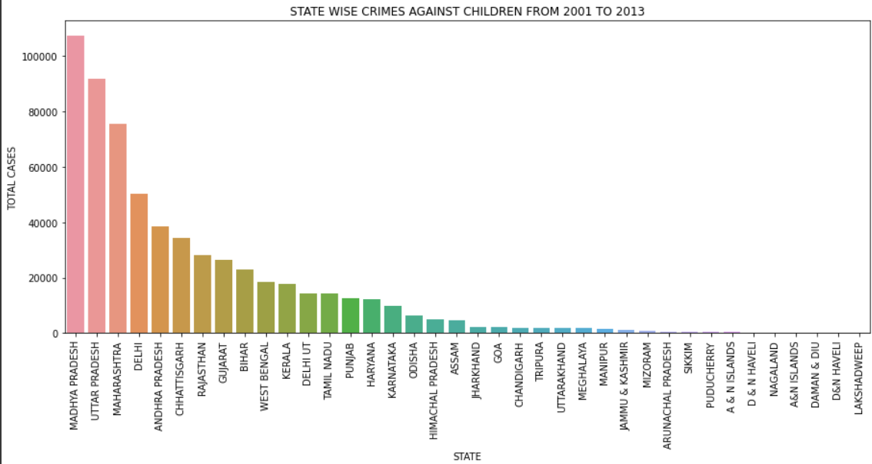

SELECT UPPER(abd.STATE) as States, sum(abd.Total_Cases) as Total_Cases FROM

(SELECT UPPER(STATE_UT) as STATE, (Rape+KidnappingandAbduction+

DowryDeaths+Assaultonwomenwithintenttooutragehermodesty+

InsulttomodestyofWomen+CrueltybyHusbandorhisRelatives+ImportationofGirls) as Total_Cases

FROM "42_District_wise_crimes_committed_against_women_2001_2012"

UNION

SELECT UPPER(STATE_UT) as STATE, (Rape+KidnappingandAbduction+

DowryDeaths+Assaultonwomenwithintenttooutragehermodesty+

InsulttomodestyofWomen+CrueltybyHusbandorhisRelatives+ImportationofGirls) as Total_Cases

FROM "42_District_wise_crimes_committed_against_women_2013"

UNION

SELECT UPPER(STATE_UT) as STATE, (TotalCrimesagainstWomen) as Total_Cases

FROM "42_District_wise_crimes_committed_against_women_2014") abd

GROUP BY abd.STATE ORDER BY Total_Cases DESC LIMIT 1;

**Andhra Pradesh has the highest crimes happened against women from 2001 to 2014.**

**Lakshadweep has the lowest crimes happened against women from 2001 to 2014.**

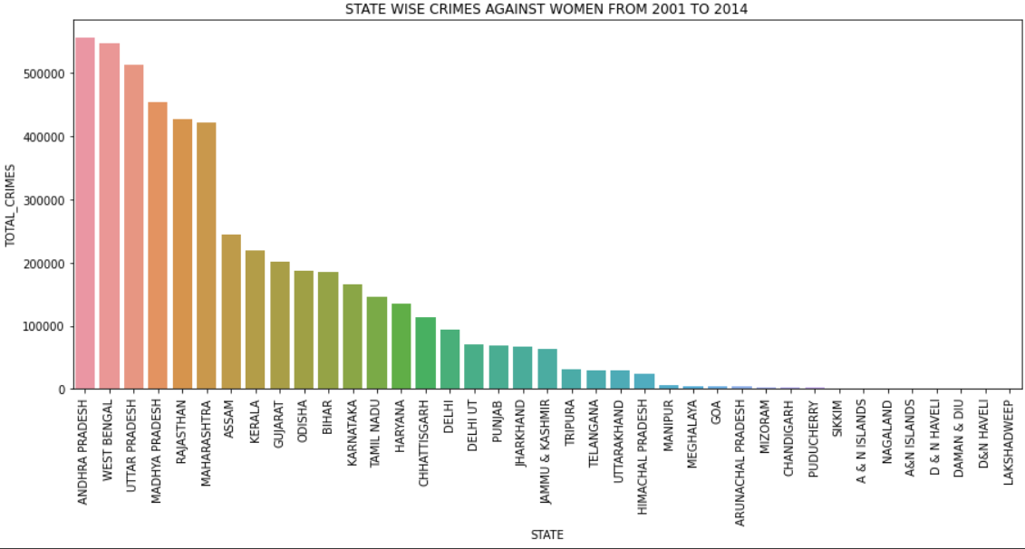

**Conclusion: Among all States, Madhya Pradesh is the highest crimes that happened against children and Andhra Pradesh is the highest crimes that happened against women**